Unit 2: Lesson 7
Let’s Eat…Nutritiously!

Goal: To learn that the physical positive action of eating nutritiously helps us be healthy and feel good about ourselves

STORY:
Have you ever had a day when you ate like this?
Cold, leftover pizza for breakfast on your way out the door…a candy bar about 11:00 because you’re hungry…French fries and some soda for lunch because you’re not hungry…chocolate chip cookies around 2:00 because your energy is drooping…more chocolate chip cookies at 2:30 and at 3:00 and at 4:00…followed by potato chips at 5:00 to tide you over until dinner.
Your family orders a pizza, and you eat a bag of chips while you wait. When dinner arrives, 4 pieces of pepperoni pizza. A couple hours later, you get a snack of chocolate peanut butter ice cream and later follow that up with some chocolate chip cookies. Then you head to bed, taking a candy bar with you, wondering why your body just isn’t as healthy as you want it to be.

Eating nutritiously is a positive action that helps us feel good about ourselves. We eat nutritiously when we eat foods that provide the nutrients our bodies need for good health. Unfortunately, in the “life-isn’t-fair” category, the foods that often taste best to us are not always the most nutritious. Our bodies sputter and choke like cars with the wrong fuel when we eat too much sugar, too much fat, or too much salt. It’s always a short trip between what we eat and how we feel.
What we eat affects us physically and it affects our self-concept. Keeping our bodies healthy by eating nutritiously helps us feel good about who we are and what we are doing. It can even be fun! There are many wonderful foods we can prepare that taste good and are nutritious, too. So, what should we eat to be healthy and to feel good about ourselves?

The U.S. Department of Agriculture has developed a general guideline to help us. This guideline is called My Plate.

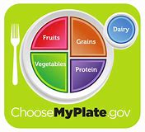

Let’s talk about this plate. The orange section of the plate tells us to eat 6 ounces of grains every day, including bread cereal, rice and pasta. The green and red sections indicate we should eat 2 ½ cups of vegetables and 2 cups of fruit each day. The dairy section says we should get 3 cups each day: they can be milk, cheese, yogurt, or other dairy products. The purple section says we should get 5 ½ ounces of meats and beans every day. Notice that there is no section for fats and sugars. This is because we should use these as sparingly as possible.
This is an example of what your plate should looklike at each serving. Eating a variety of foods, expecially grains, fruits, and vegetables, is essential to getting all the vitamins and minerals our bodies need for top performance. The plate doesn’t tell us when to eat, just how much. We have the option of trying some new things. We can create all kinds of nutritious meals.
Unfortunately, buying nutritious foods isn’t always easy. Many processed foods contain excess sugars, fats, and salt, as well as other preservatives. Until recently, nutritional information on some processed foods was incomplete or misleading. Now, a standardized Nutrition Facts label is required on most processed foods.

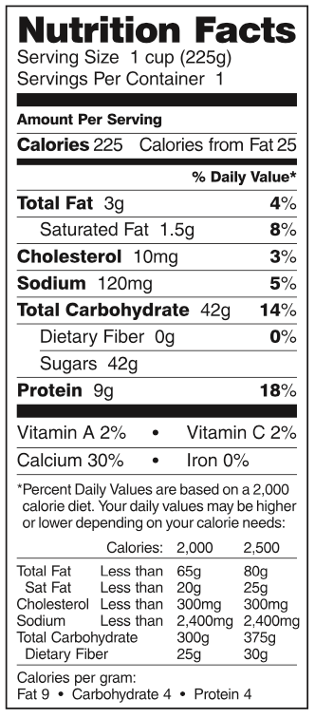
This label shows the nutritional content of one serving of the food. We can use these figures to keep track of the fat, cholesterol, sugar, and other nutrients we eat. We may also use the labels to compare sugar, fat, salt, or other nutrient content in similar foods while shopping. Or we may use them to find out which foods contain the most protein or vitamins. The Nutrition Facts label may look complicated, but reading the label becomes easy with a little practice. Of course, the foods with he most nutrients and least harmful substances don’t have labels at all - you’ll find those in the produce section of your supermarket and they’re always a good choice!
Changing our regular food choices is not always comfortable because we generally eat what tastes good to us. But our tastes are often acquired by eating the same things over and over. When changing the way we eat, it’s usually easier to add the more nutritious foods first and then slowly subtract those that are less nutritious. It’s also a good idea to drink lots of water every day.
Eating nutritiously involves not only what we should put into our bodies, but also what we shouldn’t. Alcohol, tobacco, unnecessary medicine, and illicit drugs should never be put into our bodies. Even caffeine is not healthful. These drugs have no nutritional value, and they are addictive. This “Never” category applies to adults as well as to children.
Our bodies are healthier, we have more energy, and we maintain a healthy body weight when we eat nutritiously. Peak performance requires premium fuel. Providing our bodies with the variety of nutrients we need to be healthy helps us feel good and improves our self-concepts. Eat well, be well.

QUESTIONS:
- Why is eating nutritiously a positive action?
- What are the My Plate recommendations?
- What do Nutrition Facts labels tell us?
- What happens to our bodies when we don’t eat nutritious foods?
- What substances should never be put into our bodies?
- How do our food choice affect our self-concepts?
- How do you feel about yourself when you eat nutritiously? How about when you eat junk food?
- What food group is most often on your plate? Least often?
- What food changes are you willing to make to improve your nutrition?
- How would you make these food changes?

Get a piece of paper and make a list of the foods you ate yesterday. Include all your snacks. Compare what you ate with the My Plate recommendations. Note the food groups where you ate nutritiously and where you need to make some changes. What are some changes you could make to eat more nutritiously?
Create some new menus to help you. Try adding vegetables to pastas or rice. Make some delicious fresh fruit desserts. Substitute fruits and vegetables for fats or sweets as snacks. Take a few minutes to decide on two things you are willing to do. Write out your plan.
Make a commitment to yourself to follow your pan for the next 10 days. At the end of that time, compare how you feel physically with how you feel now.

parent Positive Action

Ask Yourself: How do your eating habits make you feel about yourself as a parent? How does the food you as a parent choose to eat affect your family’s food choices? What are you teaching your children about the benefits of eating nutritiously and the dangers of using alcohol, tobacco, and other drugs? Remember, you are your children’s first and most important role model.
Plan and Do: Decide what changes you would like to make in your food choices. Write them down. Place this list where you will see it before you begin to eat. Begin making your changes at your next meal.
Not sure what changes to make? Write down everything you eat for the next three or four days, include any snacks or nibbles. Then compare what you ate to the My Plate recommendations. Determine where you could make changes and begin making them this week.
Encourage your children to cooperate with family food changes. Help them understand the amount of each food group they should eat. And have fun with the changes: make whole wheat pancakes shaped like dinosaurs or decorate veggie pizzas with crazy faces before you bake them.

FAMILY DISCUSSION:
- How do our meals compare to the My Plate recommendations?
- Which foods could we add to our family meals to make them more nutritious? Which foods should we subtract or eat less often?
- How could we make our favorite family meals more nutritious?
- How can we encourage one another to eat nutritiously?

Let’s practice the positive action of eating nutritiously by bringing our family meals more in line with the My Plate recommendations. We’ll make a list of the foods we want to add to our meals and the ones we are willing to give up or to eat less frequently. This doesn’t have to be dull, boring, or tasteless. It can be really fun! Let’s make the list now!
Take a little time to do some research on some nutritious recipes. We can find them online, in cookbooks, newspapers, magazine or on food packages. We can make a whole new menu for our family to try!

COMMUNITY POSITIVE ACTIONS:
When we go out to eat, let’s practice the positive action of eating nutritiously by keeping the My Plate recommendations in mind. We will feel good about ourselves, and our bodies will be healthier if we eat nutritiously all the time. Let’s order foods that are good for our bodies. Let’s compliment the manages of restaurants that serve healthful food and avoid restaurants that don’t.
We might want to do something about poor nutrition or substance abuse in our community. We could take pare in a food drive or volunteer to help with the community meals program. We might want to donate some time to drug abuse prevention or rehabilitation programs.

SUMMARY:
Developing nutritious eating habits pays off in a lot of positive ways. It helps our bodies, gives us more energy, and keeps us healthier. It also gives us positive feelings about ourselves, which builds our self-concepts. Comparing our own food choices with the My Plate recommendations helps us see which food changes we can make to eat more nutritiously. We can have fun while improving our nutrition by experimenting and creating new food combinations.
Since our nutritional choices affect our health and our health affects ourselves and others, we have a responsibility to eat as nutritiously as we can. Using alcohol, tobacco, or other drugs doesn’t help our bodies. Healthy bodies require nutritious foods. By making the choice to eat nutritiously, we improve our health, which helps us feel good about ourselves.

Word of the Week: Healthy
To be well or have good health.

